A000-M

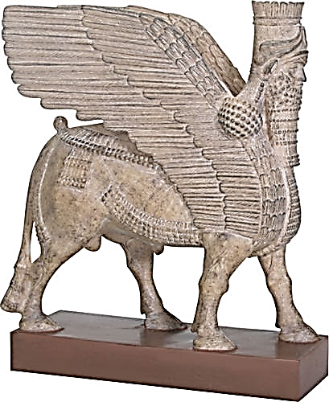

Museum Model of one of the two Lamassu guardian figures from the palace of Ashurnasirpal II (883-859 BCE) at the Assyrian capital of Nimrud (ancient Kalhu).

**Case no.:2**

**Accession Number:**

**Formal Label:** Assyria-Nimrud-Lamassu Guardian Figure-Stone-palace of Ashurnasirpal II-883-859 BC**Display Description:**

**Display Description:** In art, lumasi were depicted as [hybrids](https://en.wikipedia.org/wiki/Mythological_hybrid), with bodies of either [winged](https://en.wikipedia.org/wiki/Wing) [bulls](https://en.wikipedia.org/wiki/Bull) or [lions](https://en.wikipedia.org/wiki/Lion) and heads of human males. The motif of a winged animal with a human head is common to the Near East, first recorded in [Ebla](https://en.wikipedia.org/wiki/Ebla) around 3000 BCE. The first distinct lamassu motif appeared in Assyria during the reign of [Tiglath-Pileser II](https://en.wikipedia.org/wiki/Tiglath-Pileser_II" \o "Tiglath-Pileser II) as a symbol of power.[[9]](https://en.wikipedia.org/wiki/Lamassu#cite_note-9)[[10]](https://en.wikipedia.org/wiki/Lamassu#cite_note-10)

[Assyrian sculpture](https://en.wikipedia.org/wiki/Assyrian_sculpture) typically placed prominent pairs of lumasi at entrances in palaces, facing the street and also internal courtyards. They were represented as "double-aspect" figures on corners, in high [relief](https://en.wikipedia.org/wiki/Relief). From the front they appear to stand, and from the side, walk, and in earlier versions have five legs, as is apparent when viewed obliquely. Lumasi do not generally appear as large figures in the low-relief schemes running round palace rooms, where [winged genie](https://en.wikipedia.org/wiki/Winged_genie) figures are common, but they sometimes appear within narrative reliefs, apparently protecting the Assyrians.[[11]](https://en.wikipedia.org/wiki/Lamassu#cite_note-11)

The colossal entranceway figures were often followed by a hero grasping a wriggling lion, also colossal in scale and in high relief. In the palace of [Sargon II](https://en.wikipedia.org/wiki/Sargon_II) at [Khorsabad](https://en.wikipedia.org/wiki/Khorsabad" \o "Khorsabad), a group of at least seven lumasi and two such heroes with lions surrounded the entrance to the "throne room", "a concentration of figures which produced an overwhelming impression of power."[[12]](https://en.wikipedia.org/wiki/Lamassu#cite_note-12) They also appear on [cylinder seals](https://en.wikipedia.org/wiki/Cylinder_seal). Notable examples include those at the [Gate of All Nations](https://en.wikipedia.org/wiki/Gate_of_All_Nations) at [Persepolis](https://en.wikipedia.org/wiki/Persepolis) in Iran, the [British Museum](https://en.wikipedia.org/wiki/British_Museum) in London, the [Musée du Louvre](https://en.wikipedia.org/wiki/Mus%C3%A9e_du_Louvre" \o "Musée du Louvre) in Paris, the [National Museum of Iraq](https://en.wikipedia.org/wiki/National_Museum_of_Iraq) in Baghdad, the [Metropolitan Museum of Art](https://en.wikipedia.org/wiki/Metropolitan_Museum_of_Art) in New York and the [Oriental Institute, Chicago](https://en.wikipedia.org/wiki/Oriental_Institute,_Chicago). Several examples left *in situ* in northern [Iraq](https://en.wikipedia.org/wiki/Iraq) were destroyed in the 2010s by [ISIS](https://en.wikipedia.org/wiki/ISIS) when they occupied the area, as were [those in the Mosul Museum](https://en.wikipedia.org/wiki/Destruction_of_Mosul_Museum_artifacts#Assyrian).

Terminology[[edit](https://en.wikipedia.org/w/index.php?title=Lamassu&action=edit&section=2)]

The Lumasi represent the zodiacs, parent-stars, or constellations.[[7]](https://en.wikipedia.org/wiki/Lamassu#cite_note-ReferenceA-7)[[8]](https://en.wikipedia.org/wiki/Lamassu#cite_note-ReferenceB-8) They are depicted as protective deities because they encompass all life within them. In the [Sumerian](https://en.wikipedia.org/wiki/Sumer) [Epic of Gilgamesh](https://en.wikipedia.org/wiki/Epic_of_Gilgamesh)they are depicted as physical deities as well, which is where the Lammasu iconography originates, these deities could be microcosms of their microcosmic zodiac, parent-star, or constellation. Although "lamassu" had a different [iconography](https://en.wikipedia.org/wiki/Iconography) and portrayal in [Sumerian culture](https://en.wikipedia.org/wiki/Sumerian_culture), the terms "lamassu", "alad", and '"shedu" evolved throughout the Assyro-Akkadian culture from the Sumerian culture to denote the Assyrian-winged-man-bull symbol and statues during the [Neo-Assyrian empire](https://en.wikipedia.org/wiki/Neo-Assyrian_empire). Female lumasi were called "apsasû".[[3]](https://en.wikipedia.org/wiki/Lamassu#cite_note-Livius.org-3)

[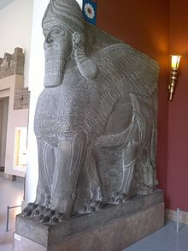](https://en.wikipedia.org/wiki/File:Door_guardian_figure_(Lamassu)_from_Nimrud_2.jpg)

Five-legged Lamassu in Berlin, with lion's feet

The motif of the Assyrian-winged-man-bull called Aladlammu and Lamassu interchangeably is not the lamassu or alad of Sumerian origin, which were depicted with different iconography.[[*clarification needed*](https://en.wikipedia.org/wiki/Wikipedia:Please_clarify)] These monumental statues were called aladlammû or lamassu which meant "protective spirit".[[3]](https://en.wikipedia.org/wiki/Lamassu#cite_note-Livius.org-3)[[*clarification needed*](https://en.wikipedia.org/wiki/Wikipedia:Please_clarify)] In Hittite, the Sumerian form dLAMMA is used both as a name for the so-called "[tutelary deity](https://en.wikipedia.org/wiki/Tutelary_deity)", identified in certain later texts with [Inara](https://en.wikipedia.org/wiki/Inara_(goddess)" \o "Inara (goddess)), and a title given to similar protective gods.[[13]](https://en.wikipedia.org/wiki/Lamassu#cite_note-13)

Mythology[[edit](https://en.wikipedia.org/w/index.php?title=Lamassu&action=edit&section=3)]

[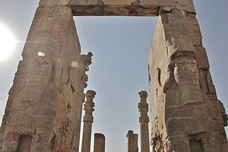](https://en.wikipedia.org/wiki/File:Gate_of_nations.JPG)

The Lamassu in [Persepolis](https://en.wikipedia.org/wiki/Persepolis)

The lamassu is a celestial being from [ancient Mesopotamian religion](https://en.wikipedia.org/wiki/Ancient_Mesopotamian_religion) bearing a human head, [bull](https://en.wikipedia.org/wiki/Bull)'s body, sometimes with the horns and the ears of a bull, and wings. It appears frequently in [Mesopotamian art](https://en.wikipedia.org/wiki/Art_of_Mesopotamia). The lamassu and shedu were household protective spirits of the common Babylonian people, becoming associated later as royal protectors, and were placed as sentinels at entrances.[[14]](https://en.wikipedia.org/wiki/Lamassu#cite_note-14) The Akkadians associated the god [Papsukkal](https://en.wikipedia.org/wiki/Papsukkal" \o "Papsukkal) with a lamassu and the god [Išum](https://en.wikipedia.org/w/index.php?title=I%C5%A1um&action=edit&redlink=1" \o "Išum (page does not exist)) with shedu.

To protect houses, the lumasi were engraved in clay tablets, which were then buried under the door's threshold. They were often placed as a pair at the entrance of [palaces](https://en.wikipedia.org/wiki/Palace). At the entrance of cities, they were sculpted in colossal size, and placed as a pair, one at each side of the door of the city, that generally had doors in the surrounding wall, each one looking towards one of the [cardinal points](https://en.wikipedia.org/wiki/Cardinal_direction).

The ancient Jewish people were influenced by the iconography of Assyrian culture. The prophet [Ezekiel](https://en.wikipedia.org/wiki/Ezekiel) wrote about a fantastic being made up of aspects of a human being, a lion, an eagle and a bull. Later, in the early Christian period, the four Gospels were ascribed to each of these components. When it was depicted in art, this image was called the [Tetramorph](https://en.wikipedia.org/wiki/Tetramorph" \o "Tetramorph).

**LC Classification:**

**Date or Time Horizon:**

**Geographical Area:**

**Map:**

**GPS coordinates:**

**Cultural Affiliation:**

**Media:**

**Dimensions:**

**Weight:**

**Condition:**

**Provenance:**

**Discussion:**

**References:**